CIS 9340 - Principles of Database Management Systems

Professor Howard Kline

05/16/2024

Krishi Shah

# **The Restaurant Database Project**

The following material documents the design and development of a database application to support a Restaurant - Gourmet Garden. The project begins with a description of the business and proceeds with logical (Relational) modeling, normalization and finally implementation of a database application.

# **I. Business Scenario**

Our restaurant, Gourmet Garden, a fine-dining Asian restaurant is nestled in the heart of New York City. Currently, our restaurant utilizes a manual method to allot tables to customers and maintain other details like their contact details and number of diners etc. We would like to streamline this process and replace this manual method by having a database.

In our restaurant, Tables are allotted to Customers upon reaching the restaurant itself. (irrespective if it's a reservation or a walk-in). We do not have takeaway or online delivery options. The Customer, once seated at the allotted table, places the order for food through a Service Staff. Based on the order taken, our Chefs prepare the food ordered by the customer.

Our Service Staff and Chefs work in different shifts to ensure we cover lunch & dinner timings and especially the weekend rush efficiently. Once the Customer finishes the meal, a bill gets generated for the order. Customers can pay the bill through three payment options: Cash/Debit Card/Credit Card. Our restaurant also provides a feedback form to the customer at the time of payment to understand their experience at the restaurant.

***Commentary:***

Based on the above description, we constructed a Relational Model that captures all the business data needs.

**Relationship Sentences:**

One **Customer** will be assigned one **table number**.

One **table number** will be assigned to one and only one **Customer**.

One **Service Staff** will take one or more **Orders**.

One **Order** must be taken by one and only one **Service Staff**.

One **Chef** will prepare one or more **Orders**.

One **Order** will be prepared by one or many **Chefs**.

One **Service Staff** will serve one or more **Customers**.

One **Customer** must be served by one and only one **Service Staff**.

One **Order** generates one and only one **Bill**.

One **Bill** will be generated for one **Order**.

One **Payment** will be paid for one and only one **Bill**.

One **Bill** will be paid by one and only one **Payment**.

One **Payment** will be made using one or more **Payment Methods** (Credit Card, Debit Card & Cash).

One **Payment Method** will be used for one or more **Payments**.

One **Customer** will provide one or more **Feedback**.

One **Feedback** is provided by one and only one **Customer**.

***Commentary:***

The relationship sentences should make sense. In this example, the verb phrases are underlined. The entity names are in bold letters.

# **II. The Relational Model**

The next step is to [Draw the Relational Model](https://lucid.app/lucidchart/b22008d6-fcf0-4df5-bebf-a63ad51fb3de/edit?invitationId=inv_70fc9196-8311-4f81-b825-939c86af38d7&page=0_0)[.](http://holowczak.com/converting-e-r-models-to-relational-models/) During this step, Identifiers in the Entities become Keys in the Relations. One-to-many relationships result in a foreign key being copied from the One side to the Many side of the relationship.

**Customer** (CustomerID (PK), CustomerFirstName, CustomerLastName, CustomerContactNo, CStreetName, CState, CZipcode, TableNo (FK), RegistrationID (FK), ServiceStaff ID (FK))

**GourmetGarden** (RegistrationID (PK), RestaurantContactNo, RestaurantAddress, RestaurantOperationalHours, RestaurantWebsiteURL)

**Tables** (TableNo (PK), NoOfDiners, TypeOfBooking, TypeOfTable, CustomerID (FK))

**Feedback** (FeedbackID (PK), DateOfFeedback, TimeOfFeedback, CustomerComments, CustomerRatings, CustomerID (FK))

**ServiceStaff** (ServiceStaffID (PK), SSName, SSContactNo, SSHomeAddress, SSRateOfPay, ShiftID (FK), RegistrationID (FK))

**Shift** (ShiftID (PK), ShiftStartTime, ShiftEndTime, Role)

**Chef** (ChefID (PK), ChefName, ChefContactNo, ChefHomeAddress, ChefRateOfPay, RegistrationID (FK), ShiftID (FK))

**Chef Order** (ChefID (FK), OrderID (FK))

**Orders** (OrderID (PK), OrderDate, OrderTime, FoodItemName, Quantity, Allergens, SpiceLevel, BillID (FK), ServiceStaffID (FK))

**Payments** (PaymentID (PK), PaymentMethod, DateOfPayment, TimeOfPayment, BillID (FK))

**Bill** (BillID (PK), BillAmount, BillReceiptMode, PaymentID (FK), OrderID (FK))

**Credit Card** (CreditID (PK), PaymentID (FK))

**Debit Card** (DebitID (PK), PaymentID (FK))

**Cash** (CashID (PK), PaymentID (FK))

This is the “initial set of relations.”

***Commentary:***

Primary Keys are shown with the PK designation. Foreign keys are shown with the FK designation.

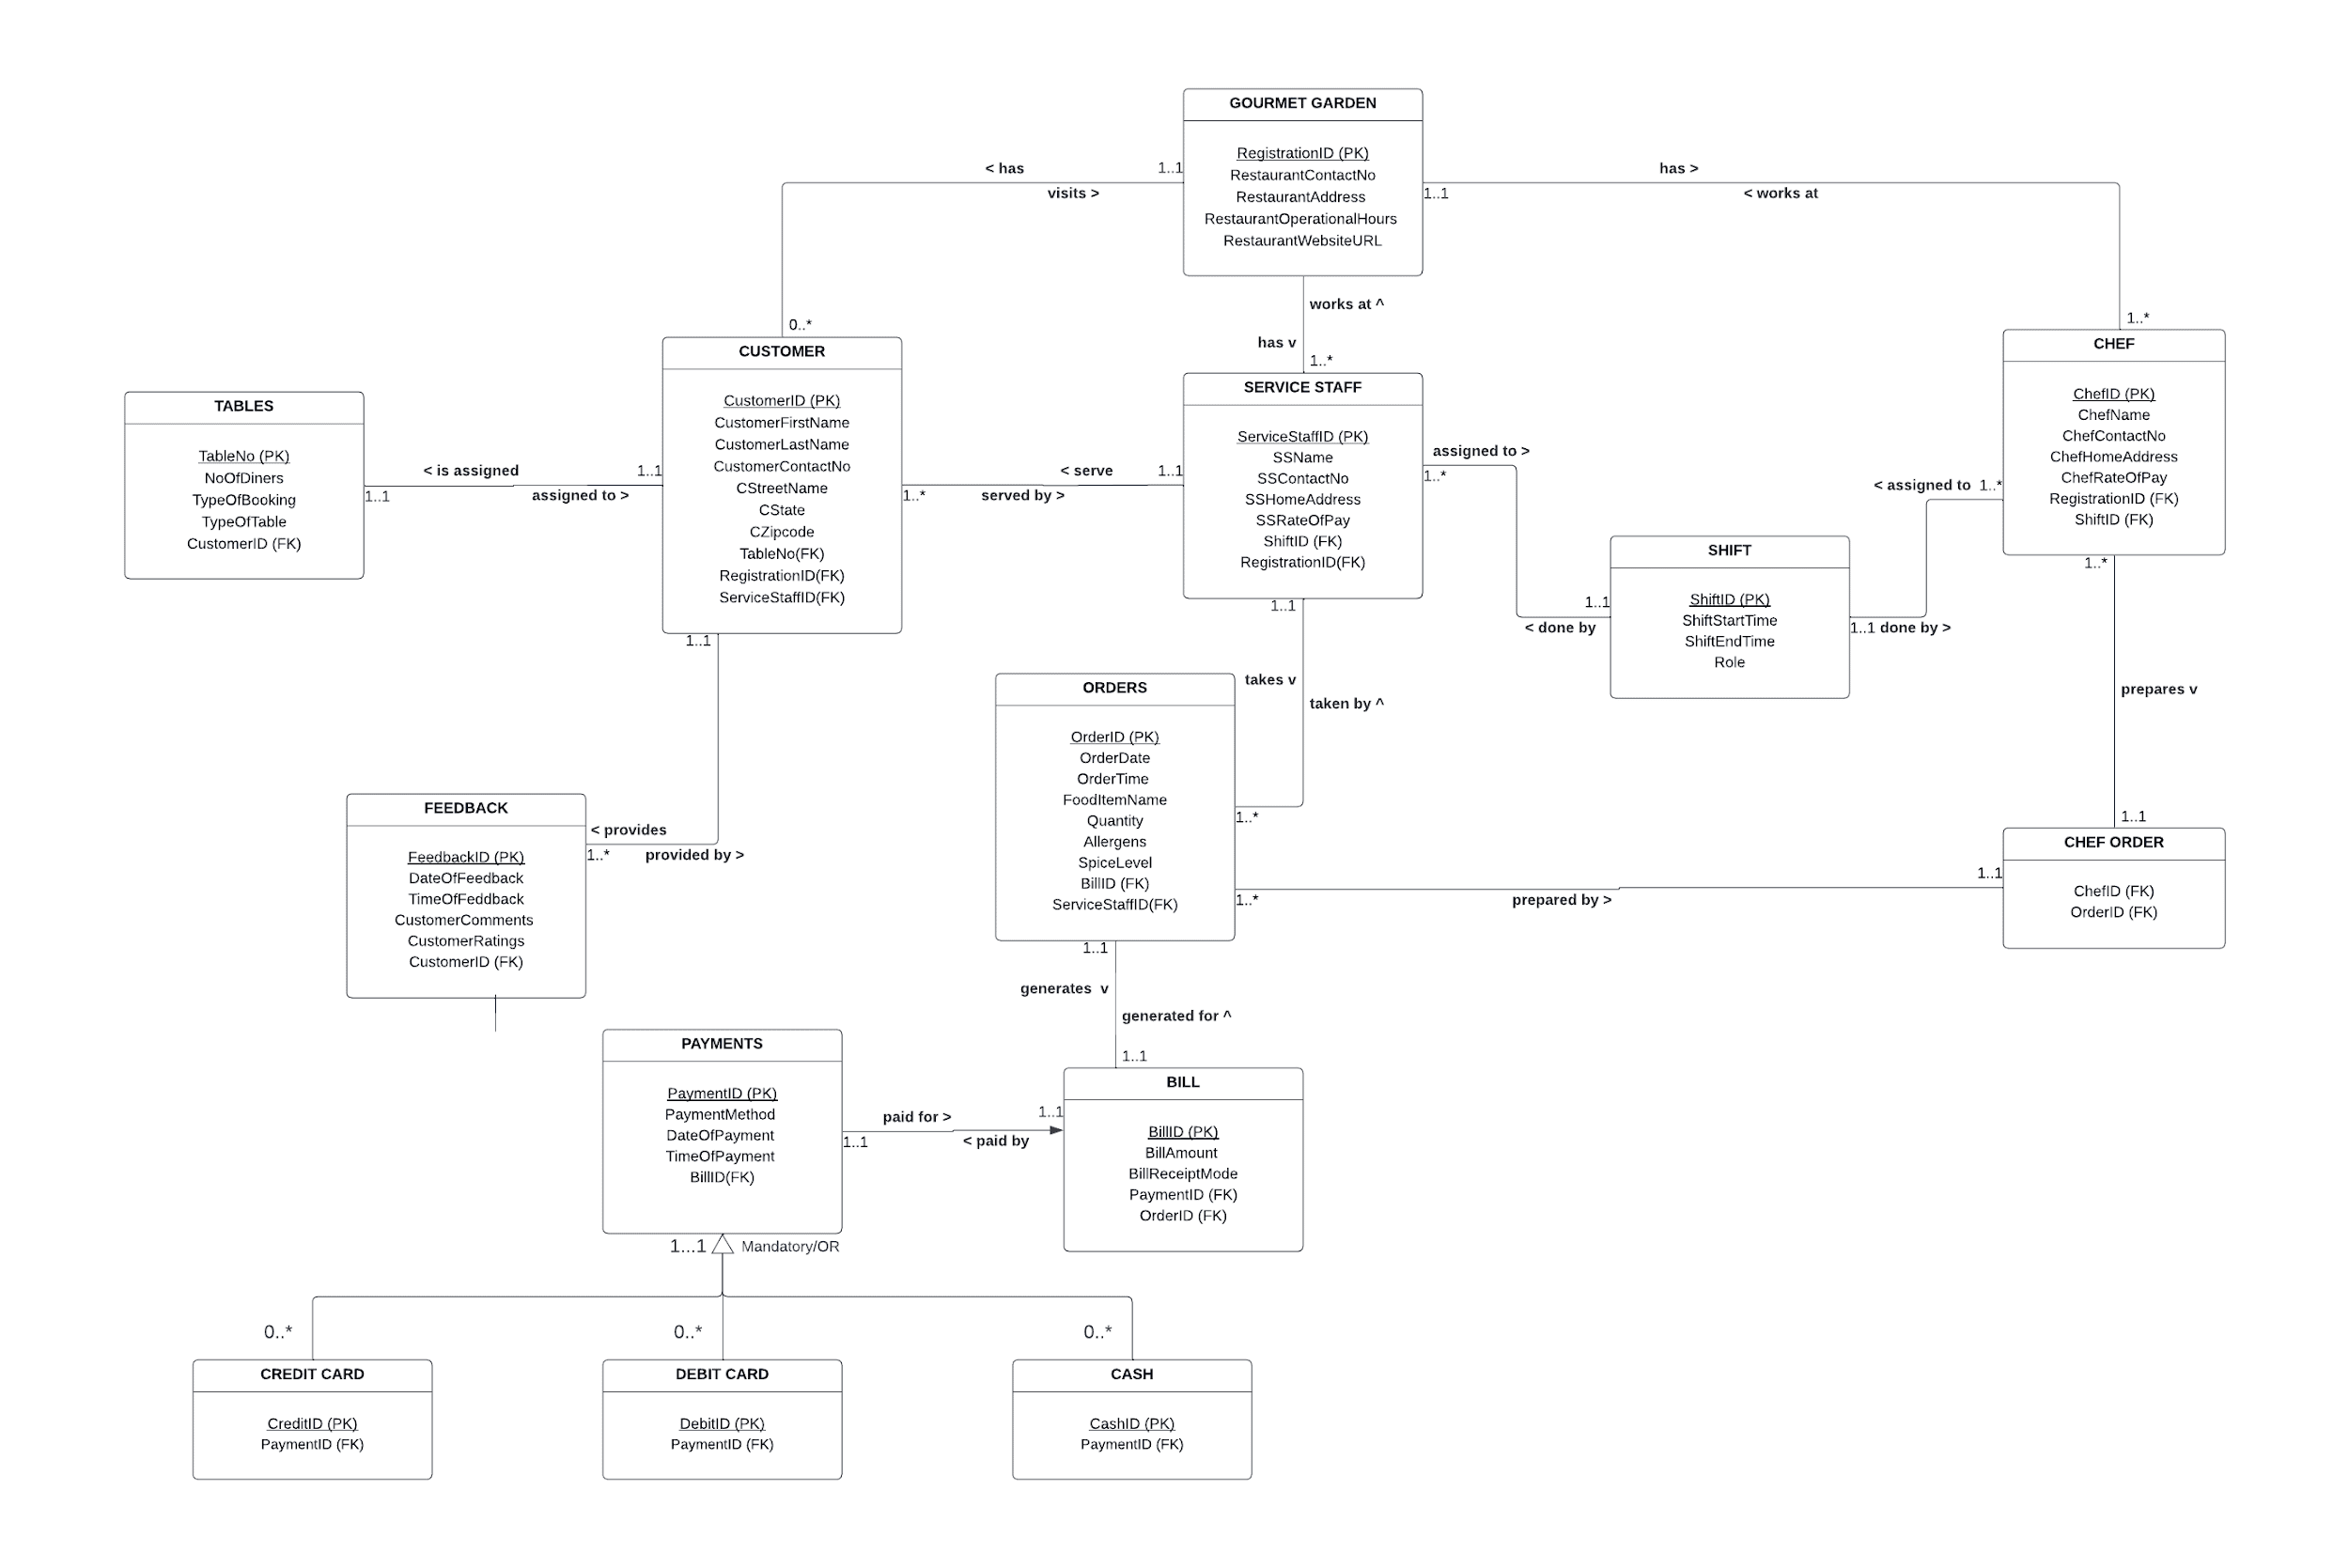

Screenshot: Our Relational Model Screenshot from Lucidchart

# **III. Normalization**

The next step is to Normalize the Relations[.](http://holowczak.com/database-normalization/) We selected four tables on a random basis.

1. **Tables**

|  |  |  |  |  |
| --- | --- | --- | --- | --- |
| **TABLES** | | | | |
| **TableNo. (PK)** | **NoOfDiners** | **TypeOfBooking** | **TypeOfTable** | **CustomerID (FK)** |
| T1 | 4 | Reservation | Outdoor Seating | GG0001 |
| T2 | 2 | Reservation | Indoor Seating | GG0002 |
| T3 | 6 | Reservation | Outdoor Seating | GG0003 |
| T4 | 3 | Reservation | Rooftop Seating | GG0004 |
| T5 | 5 | Reservation | Indoor Seating | GG0005 |
| T6 | 2 | Walk-In | Rooftop Seating | GG0012 |
| T7 | 1 | Walk-In | Indoor Seating | GG0010 |
| **Primary Key:** TableNo.  **Solution:** The table is in 3NF basis the below working:  **1NF:** Meets the definition of a relation  **2NF:** No partial Key dependencies and all non-key attributes are fully functional dependent on 'TableNo.'  **3NF:** No transitive dependencies | | | | |

1. **Bill**

|  |  |  |  |  |
| --- | --- | --- | --- | --- |
| **BILL** | | | | |
| **BillID (PK)** | **BillAmount** | **BillReceiptMode** | **PaymentID (FK)** | **OrderID (FK)** |
| BILL125 | $50 | Print | P2001 | O1001 |
| BILL126 | $35 | Email | P2002 | OI002 |
| BILL127 | $20 | Print | P2003 | OI003 |
| BILL128 | $45 | Print | P2004 | OI004 |
| BILL129 | $28 | Email | P2005 | OI005 |
| BILL121 | $25 | Print | P2008 | OI115 |
| **Primary Key:** Bill ID  **Solution:** The table is in 3NF basis the below working:  **1NF:** BILL(BillID (PK), BillAmount, BillReceiptMode, OrderID (FK), PaymentID (FK)). This meets the definition of a relation.  **2NF:** No partial key dependencies and all non-key attributes are fully functional dependent on 'Bill ID'.  **3NF:** No transitive dependencies. | | | | |

1. **Payments**

|  |  |  |  |  |
| --- | --- | --- | --- | --- |
| **PAYMENTS** | | | | |
| **PaymentID (PK)** | **PaymentMethod** | **DateOfPayment** | **TimeOfPayment** | **BillID (FK)** |
| P2001 | Cash | 2024-05-02 | 12:45 PM | BILL125 |
| P2002 | Debit Card | 2024-05-02 | 1:30 PM | BILL126 |
| P2003 | Cash | 2024-05-02 | 2:15 PM | BILL127 |
| P2004 | Credit Card | 2024-05-02 | 7:30 PM | BILL128 |
| P2005 | Credit Card | 2024-05-02 | 7:45 PM | BILL129 |
| P2033 | Debit Card | 2024-05-04 | 8:00 PM | BILL551 |
| P2056 | Cash | 2024-05-04 | 6:30 PM | BILL665 |
| **Primary Key:** PaymentID  **Solution:** The table is in 3NF basis the below working:  **1NF:** This meets the definition of a relation because PaymentID is the unique identifier for each row.  **2NF:** There are no partial key dependencies because all attributes in the table are fully dependent on PaymentID.  **3NF:** There are no transitive dependencies. | | | | |

1. **Orders**

|  |  |  |  |  |  |  |  |  |
| --- | --- | --- | --- | --- | --- | --- | --- | --- |
| **ORDERS** | | | | | | | | |
| **OrderID (PK)** | **OrderDate** | **OrderTime** | **FoodItemName** | **Quantity** | **Allergens** | **SpiceLevel** | **BillID (FK)** | **ServiceStaffID (FK)** |
| OI001 | 2024-05-02 | 12:30 PM | Pad Thai | 2 | None | Medium | BILL125 | SS1 |
| OI002 | 2024-05-02 | 1:15 PM | Sushi Rolls | 1 | None | Mild | BILL126 | SS2 |
| OI003 | 2024-05-02 | 2:00 PM | Pho | 1 | None | None | BILL127 | SS3 |
| OI004 | 2024-05-02 | 3:00 PM | Dim Sum | 2 | Gluten | Spicy | BILL128 | SS4 |
| OI005 | 2024-05-02 | 4:30 PM | Ramen | 1 | None | Medium | BILL129 | SS5 |
| OI010 | 2024-05-03 | 3:00 PM | Sushi Rolls | 2 | None | Mild | BILL256 | SS11 |
| OI023 | 2024-05-03 | 5:00 PM | Miso Soup | 3 | Gluten | Medium | BILL290 | SS10 |
| **Primary Key:** OrderID  **Solution:** The table is in 3NF basis the below working:  **1NF:** Meets the definition of a relation  **2NF:** No partial Key dependencies and all non-key attributes are fully functionally dependent on 'OrderID'  **3NF:** No transitive dependencies | | | | | | | | |

# **IV. DDL Statements - Structured Query Language (SQL) to Create the Schema**

Create a table in the database for each of the relations in the final set of relations.

The following SQL code creates the tables and adds the PRIMARY KEY constraint to each one:

CREATE TABLE Tables(

TableNo Varchar(25) NOT NULL,

NoOfDiners Numeric(10) NOT NULL,

TypeOfBooking Varchar(30) NOT NULL,

TypeOfTable Varchar(40) NOT NULL,

CustomerID Varchar(25) NOT NULL,

CONSTRAINT Table_PK PRIMARY KEY (TableNo)

);

CREATE TABLE Shift (

ShiftID Varchar(25) NOT NULL,

ShiftStartTime Varchar(25) NOT NULL,

ShiftEndTime Varchar(25) NOT NULL,

Role Varchar(60) NOT NULL,

CONSTRAINT Shift1_PK PRIMARY KEY (ShiftID)

CREATE TABLE Payments(

PaymentID Varchar(25) NOT NULL,

PaymentMethod Varchar(25) NOT NULL,

DateOfPayment Varchar(30) NOT NULL,

TimeOfPayment Varchar(30) NOT NULL,

BillID Varchar(25) NOT NULL,

CONSTRAINT Payments_PK PRIMARY KEY (PaymentID)

);

CREATE TABLE GourmetGarden (

RegistrationID Varchar(10) NOT NULL,

RestaurantContactNo Numeric(10) NOT NULL,

RestaurantAddress Varchar(35) NOT NULL,

RestaurantOperationalHours Varchar(45) NOT NULL,

RestaurantWebsiteURL Varchar(45) NOT NULL,

CONSTRAINT Table_PK PRIMARY KEY (RegistrationID)

);

CREATE TABLE Bill (

BillID Varchar(25) NOT NULL,

BillAmount Varchar(25) NOT NULL,

BillReceiptMode Varchar(25) NOT NULL,

PaymentID Varchar(25) NOT NULL,

OrderID Varchar(25) NOT NULL,

CONSTRAINT Bill1_PK PRIMARY KEY (BillID)

);

CREATE TABLE Feedback(

FeedbackID Varchar(25) NOT NULL,

DateOfFeedback Varchar(25) NOT NULL,

TimeOfFeedback Varchar(25) NOT NULL,

CustomerComments Varchar(60) NOT NULL,

CustomerRatings Varchar(10) NOT NULL,

CustomerID Varchar(25) NOT NULL,

CONSTRAINT Feedback_PK PRIMARY KEY (FeedbackID),

CONSTRAINT Cus_FK FOREIGN KEY (CustomerID)

REFERENCES Customer (CustomerID)

ON DELETE CASCADE ON UPDATE CASCADE

);

CREATE TABLE Orders(

OrderID Varchar(25) NOT NULL,

OrderDate Varchar(25) NOT NULL,

OrderTime Varchar(25) NOT NULL,

FoodItemName Varchar(25) NOT NULL,

Quantity Varchar(10) NOT NULL,

Allergens Varchar(45) NOT NULL,

SpiceLevel Varchar(25) NOT NULL,

BillID Varchar(25) NOT NULL,

ServiceStaffID Varchar(25) NOT NULL,

CONSTRAINT Order_PK PRIMARY KEY (OrderID),

CONSTRAINT Ser_FK FOREIGN KEY (ServiceStaffID)

REFERENCES ServiceStaff(ServiceStaffID)

ON DELETE CASCADE ON UPDATE CASCADE

);

CREATE TABLE DebitCard (

DebitID Varchar(25) NOT NULL,

PaymentID Varchar(25) NOT NULL,

CONSTRAINT DC_PK PRIMARY KEY (DebitID),

CONSTRAINT Pay1_FK FOREIGN KEY (PaymentID)

REFERENCES Payments (PaymentID)

ON DELETE CASCADE ON UPDATE CASCADE

);

CREATE TABLE ServiceStaff (

ServiceStaffID Varchar(25) NOT NULL,

SSName Varchar(25) NOT NULL,

SSContactNo Numeric(10) NOT NULL,

SSHomeAddress Varchar(60) NOT NULL,

SSRateOfPay Varchar(10) NOT NULL,

ShiftID Varchar(25) NOT NULL,

RegistrationID Varchar(10) NOT NULL,

CONSTRAINT ServStaff_PK PRIMARY KEY (ServiceStaffID),

CONSTRAINT SS1_FK FOREIGN KEY (ShiftID)

REFERENCES SHIFT (ShiftID)

ON DELETE CASCADE ON UPDATE CASCADE,

CONSTRAINT SS2_FK FOREIGN KEY (RegistrationID)

REFERENCES GourmetGarden(RegistrationID)

ON DELETE CASCADE ON UPDATE CASCADE

);

CREATE TABLE CreditCard (

CreditID Varchar(25) NOT NULL,

PaymentID Varchar(25) NOT NULL,

CONSTRAINT CC_PK PRIMARY KEY (CreditID),

CONSTRAINT Pay_FK FOREIGN KEY (PaymentID)

REFERENCES Payments (PaymentID)

ON DELETE CASCADE ON UPDATE CASCADE

);

CREATE TABLE Cash (

CashID Varchar(25) NOT NULL,

PaymentID Varchar(25) NOT NULL,

CONSTRAINT Cash_PK PRIMARY KEY (CashID),

CONSTRAINT Pay2_FK FOREIGN KEY (PaymentID)

REFERENCES Payments (PaymentID)

ON DELETE CASCADE ON UPDATE CASCADE

);

CREATE TABLE Customer(

CustomerID Varchar(25) NOT NULL,

CustomerFirstName Varchar(45) NOT NULL,

CustomerLastName Varchar(45) NOT NULL,

CustomerContactNo Numeric(10) NOT NULL,

CStreetName Varchar(45) NOT NULL,

CState Varchar(45) NOT NULL,

CZipcode Numeric(5) NOT NULL,

TableNo Varchar(25) NOT NULL,

RegistrationID Varchar(10) NOT NULL,

ServiceStaffID Varchar(25) NOT NULL,

CONSTRAINT Cust_PK PRIMARY KEY (CustomerID),

CONSTRAINT Reg_FK FOREIGN KEY (RegistrationID)

REFERENCES GourmetGarden (RegistrationID)

ON DELETE CASCADE ON UPDATE CASCADE,

CONSTRAINT Ser1_FK FOREIGN KEY (ServiceStaffID)

REFERENCES ServiceStaff(ServiceStaffID)

ON DELETE CASCADE ON UPDATE CASCADE

);

CREATE TABLE Chef(

ChefID Varchar(10) NOT NULL,

ChefName Varchar(45) NOT NULL,

ChefContactNo Numeric(10) NOT NULL,

ChefHomeAddress Varchar(45) NOT NULL,

ChefRateOfPay Varchar(15) NOT NULL,

ShiftID Varchar(25) NOT NULL,

RegistrationID Varchar(10) NOT NULL,

CONSTRAINT Cust_PK PRIMARY KEY (ChefID),

CONSTRAINT S_FK FOREIGN KEY (ShiftID)

REFERENCES SHIFT (ShiftID)

ON DELETE CASCADE ON UPDATE CASCADE,

CONSTRAINT S1_FK FOREIGN KEY (RegistrationID)

REFERENCES GourmetGarden(RegistrationID)

ON DELETE CASCADE ON UPDATE CASCADE

);

Create TABLE ChefOrder (

ChefID Varchar(10) NOT NULL,

OrderID Varchar(25) NOT NULL,

CONSTRAINT ChefOrder_PK PRIMARY KEY (ChefID,OrderID),

CONSTRAINT CO1_FK FOREIGN KEY (ChefID)

REFERENCES CHEF (ChefID)

ON DELETE CASCADE ON UPDATE CASCADE,

CONSTRAINT CO2_FK FOREIGN KEY (OrderID)

REFERENCES ORDERS (OrderID)

ON DELETE CASCADE ON UPDATE CASCADE

);

ALTER table Feedback DROP TimeOfFeedback

ALTER TABLE Shift ADD Notes Text(50) NOT NULL;

INSERT INTO Shift ( ShiftID, ShiftStartTime, ShiftEndTime, Role, Notes )

VALUES ('CH1', '10:00AM', '5:00 PM', 'Morning Chef', 'None');

INSERT INTO GourmetGarden ( RegistrationID, RestaurantContactNo, RestaurantAddress, RestaurantOperationalHours, RestaurantWebsiteURL )

VALUES ('GG56743125', 1234567890, '123 Main St, Elm St., NY, 12345', '11:00 AM - 11:00 PM', 'https://www.gourmetgarden.com');

INSERT INTO Chef ( ChefID, ChefName, ChefContactNo, ChefHomeAddress, ChefRateOfPay, ShiftID, RegistrationID )

VALUES ('C102', 'Aurora Stone', '9876543210', '456 Park Avenue, Brooklyn, NY 11201', '$30', 'CH2', 'GG56743125');

INSERT INTO Chef ( ChefID, ChefName, ChefContactNo, ChefHomeAddress, ChefRateOfPay, ShiftID, RegistrationID )

VALUES ('C101', 'Xavier Blackwood', '5637897890', '123 Broadway, New York, NY 10001', '$25', 'CH1', 'GG56743125');

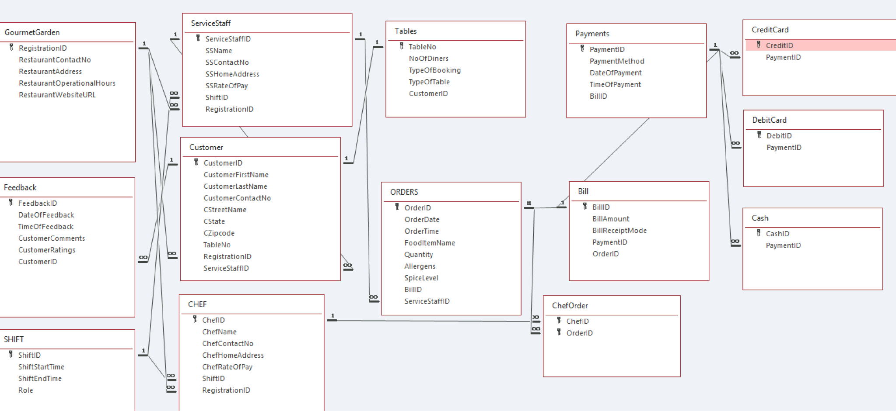

Screenshot: Relationship view of our Database

# **V. DML Statements - Using DML Statements to interact with our database**

**Query 1: Using SELECT and FROM Framework**

SELECT RestaurantWebsiteURL

FROM GourmetGarden;

**Query 2: Using SELECT, FROM and WHERE Framework**

SELECT *

FROM Orders

WHERE FoodItemName='Dim Sum';

**Query 3: Using SELECT Statement**

SELECT FoodItemName, Quantity, Allergens, SpiceLevel

FROM Orders;

**Query 4: Using DISTINCT**

SELECT DISTINCT ServiceStaffID

FROM Orders;

**Query 5: Using Calculated Fields**

SELECT SSName, SSContactNo, SSRateOfPay, SSRateOfPay*6 AS SSPerDayRate

FROM ServiceStaff;

**Query 6: Using Comparison Search Condition**

SELECT CustomerFirstName, CustomerLastName, CustomerContactNo, CState, CZipcode

FROM Customer

WHERE CState='NY' OR CState='PA';

**Query 7: Using Range Search Condition**

SELECT TableNo,NoOfDiners,CustomerID

FROM Tables

WHERE NoOfDiners>=5 AND NoOfDiners<=8;

**Query 8: Using Compound Comparison Search Condition**

SELECT ShiftID, Role

FROM Shift

WHERE Role='Senior Service Staff' OR Role='Senior Chef';

**Query 9: Using Pattern Matching**

SELECT CustomerComments,CustomerRatings,CustomerID

FROM Feedback

WHERE CustomerComments LIKE '%excellent%';

**Query 10: Using Ordering**

SELECT BillID,BillAmount

FROM Bill

ORDER BY BillAmount DESC;

**Query 11: Using Count**

SELECT COUNT(* ) AS MyCount

FROM Shift

WHERE ShiftStartTime='11:00AM';

**Query 12: Using Min, Max & Average**

SELECT MIN(SSRateOfPay) AS MinRate,

MAX(SSRateOfPay) AS MaxRate,

AVG(SSRateOfPay) AS AvgRate

FROM ServiceStaff;

**Query 13: Using Group By**

SELECT BillReceiptMode, COUNT(*) AS NumberOfBills, SUM(BillAmount) AS TotalRevenue

FROM Bill

GROUP BY BillReceiptMode;

**Query 14: Using Group By & Order By**

SELECT TableNo, COUNT(TableNo) AS NumberOfTables

FROM Customer

GROUP BY TableNo

ORDER BY TableNo;

**Query 15: Using Having**

SELECT ServiceStaffID AS SSID, COUNT(*) AS NumberOfOrders

FROM Orders

GROUP BY ServiceStaffID

HAVING COUNT(*) > 1

ORDER BY ServiceStaffID;

**Query 16: Using Join**

SELECT Customer.CustomerID, Customer.ServiceStaffID, Customer.CustomerFirstName, Customer.CustomerLastName

FROM Customer, ServiceStaff

WHERE Customer.ServiceStaffID = ServiceStaff.ServiceStaffID

AND Cstate='NJ';

**Query 17: Using Subquery**

SELECT BillID, BillAmount, BillReceiptMode, PaymentID

FROM Bill

WHERE BillID IN

(SELECT BillID

FROM Payments

WHERE PaymentID IN

(SELECT paymentID

FROM Bill

WHERE PaymentMethod ='Credit Card'

AND BillAmount >'30'));

**Query 18:** **Using Update**

UPDATE Bill SET Bill.BillAmount = "52"

WHERE ((Bill.BillAmount)="40");

**Query 19:** **Using Subquery**

SELECT Orders.OrderID, Orders.FoodItemName, Orders.Allergens, Orders.SpiceLevel

FROM Orders

WHERE OrderID IN

(SELECT OrderID

FROM Bill

WHERE SpiceLevel='Spicy');

**Query 20: Using Join**

SELECT Orders.ServiceStaffID, Orders.FoodItemName, Orders.Allergens, Orders.SpiceLevel

FROM Orders, ServiceStaff

WHERE Orders.ServiceStaffID=ServiceStaff.ServiceStaffID

AND FoodItemName='Dim Sum'

AND Allergens='None';

**Query 21: Using Delete**

DELETE *

FROM Customer

WHERE CustomerFirstName='Olivia';